- Repository
https://github.com/satyam2428cs2299-create/github-skills-challenge
- Pull request
https://github.com/satyam2428cs2299-create/github-skills-challenge/pull/1
- Actions
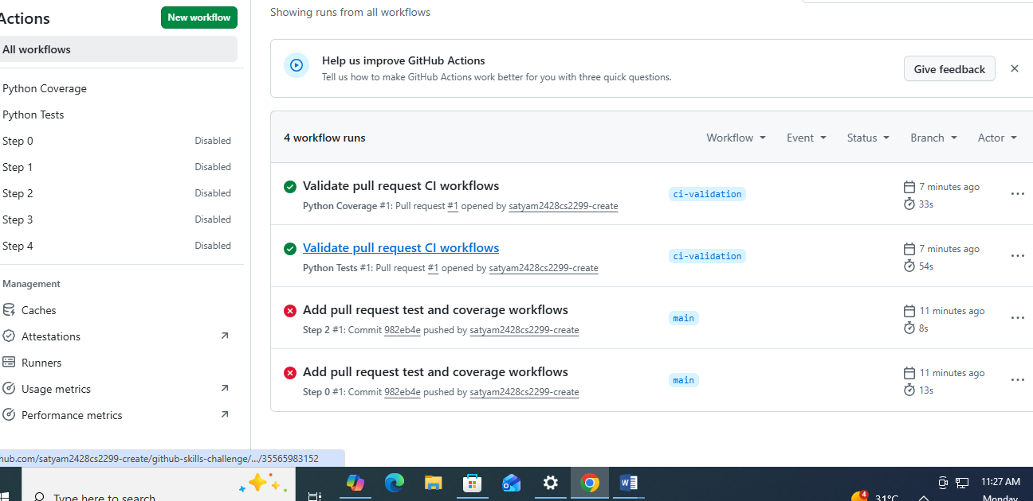

4-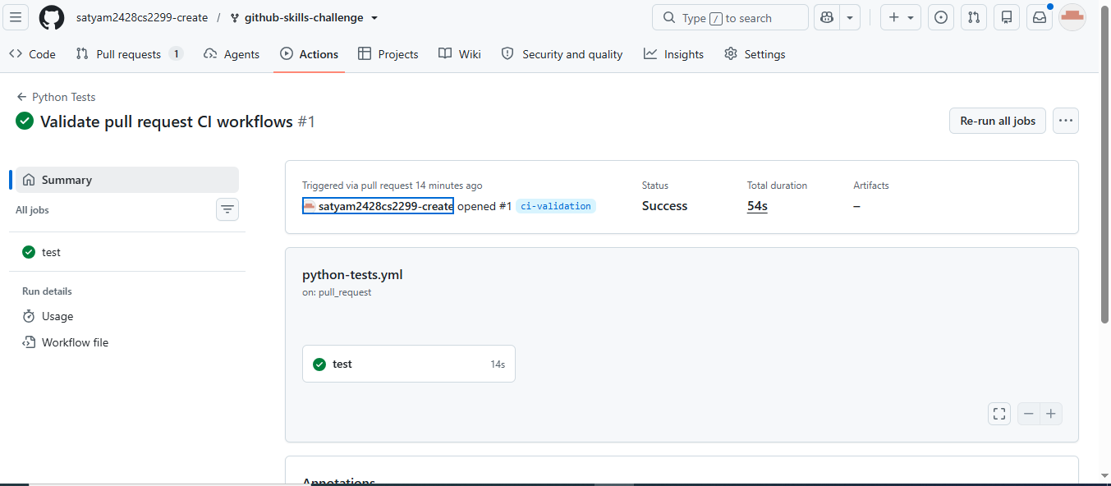
5-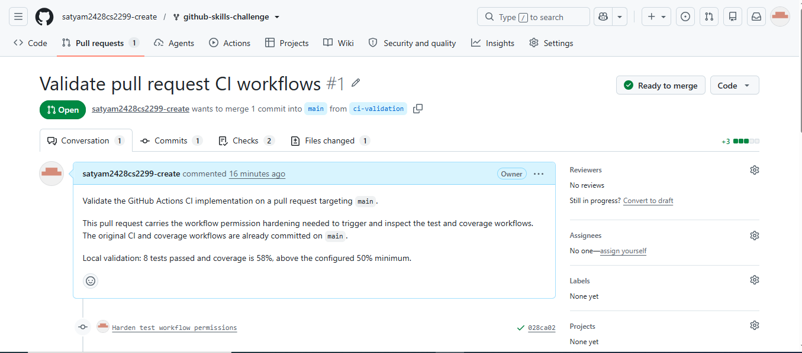
6-
